Process for entering Spike/Referred By Information for Auto-Processing via BillHighway
This document covers the steps that need to be taken for the referral information to be properly recorded and sent to NAHB via the Dues Hub/BillHighway integration. This information is sent at the time of membership approval, if Spike is added after approving the new member application the association will need to email both BillHighway and NAHB.
-When an application is filled out, there is a custom field called Who invited You to Join?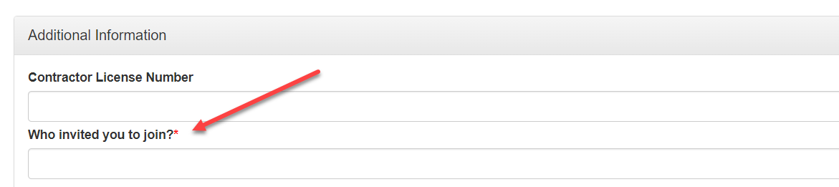
-Before approving the new member application, the Who Invited You to Join (Spike) information needs to be copied and pasted to the Membership Details in the Spike Contact field.
1. Go to Memberships --> Submitted Applications, they can click on the name of the membership.
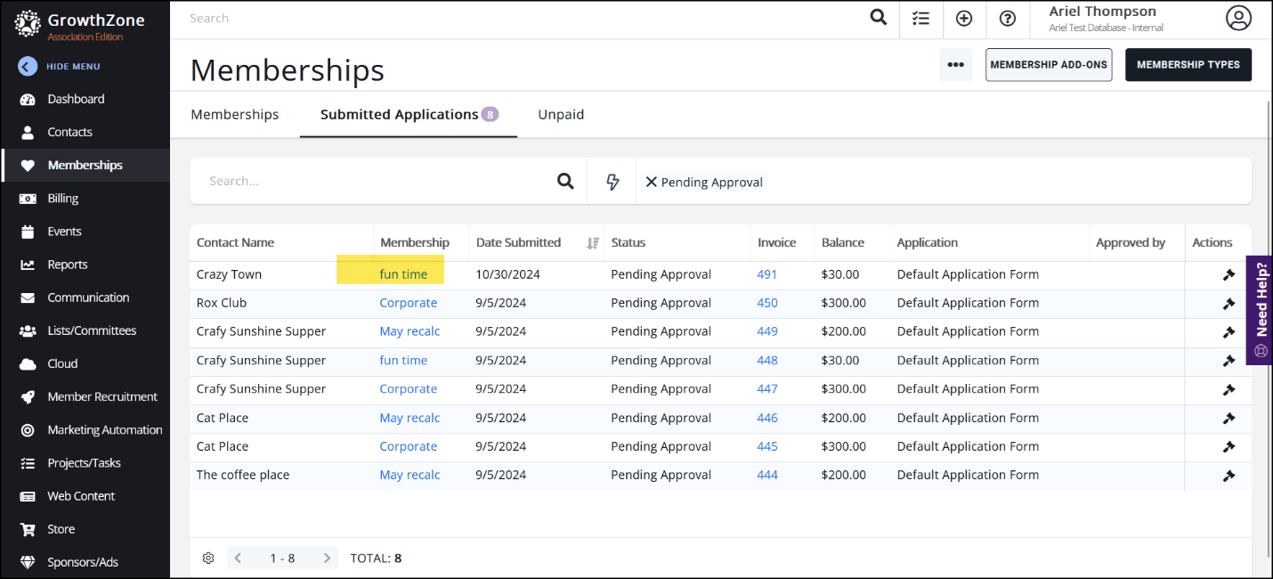
2. On the Edit Membership Details Screen enter the name in the Spike Field (or Referred By contact field.
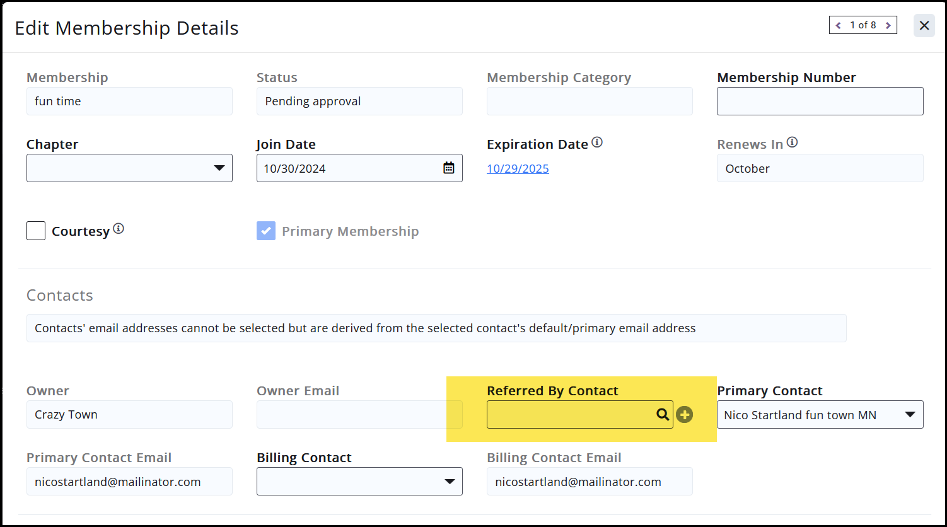

- When pasted in, GrowthZone will search your existing database to make a match. This match cannot happen at the application level but is important because it will send both the name and the PIN of the referral to Dues Hub:

Once this process is complete, the membership is then approved and, if paid by credit card or ACH, will send the payment, membership information and the referral/Spike to Dues Hub and then forwarded to NAHB.

